**SUPER STORE SALES ANALYSIS**

**BY USING POWER BI**

**OBJECTIVE:**

To contribute to the success of a business by utilizing data analysis techniques, specifically focusing on time series analysis, to provide valuable insights and accurate sales forecasting.

**DESCRIPTION:**

The objective can be broken down into the following detailed components:

1.Dashboard Creation: Identify the KPIs, design an intuitive and visually appealing dashboard, add interactive visualizations and filtering capabilities to allow users to explore the data at various levels of granularity

2.Data Analysis: Provide valuable insights to business entities regarding the effectiveness of their sales strategies through visualization and charts.

3.Sales Forecasting: Leverage historic data and apply time series generate sales forecasts for next 15 days.

4.Actionable Insights and Recommendations: End goal is to share valuable insights and actionable information that can drive strategic decision-making and support the supermarket's goals for growth, efficiency, and customer satisfaction.

**SUPER SALES STORE DASHBOARD:**

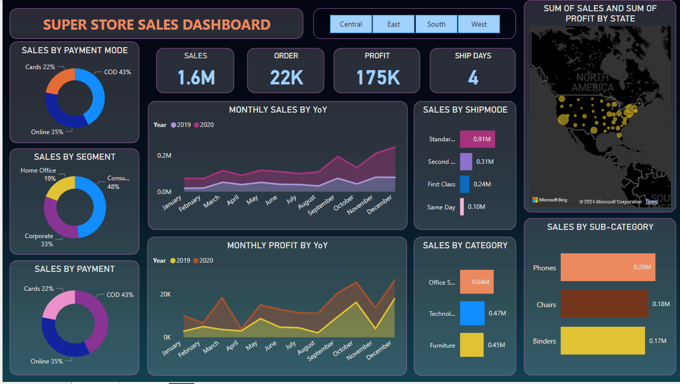

By Using Power BI, I analyse Superstore Sales in United States of America in Central, East, South and West Region.

* **CENTRAL REGION:**

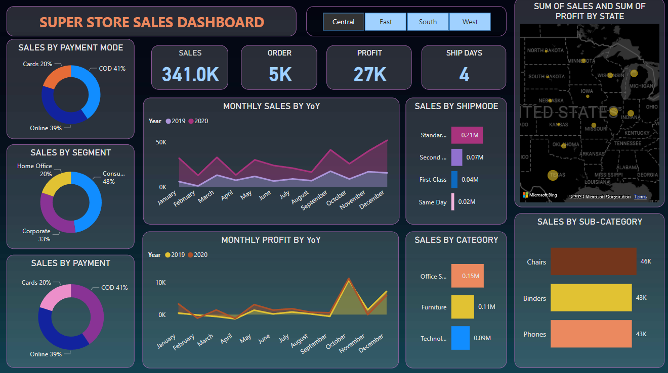

* **EAST REGION:**

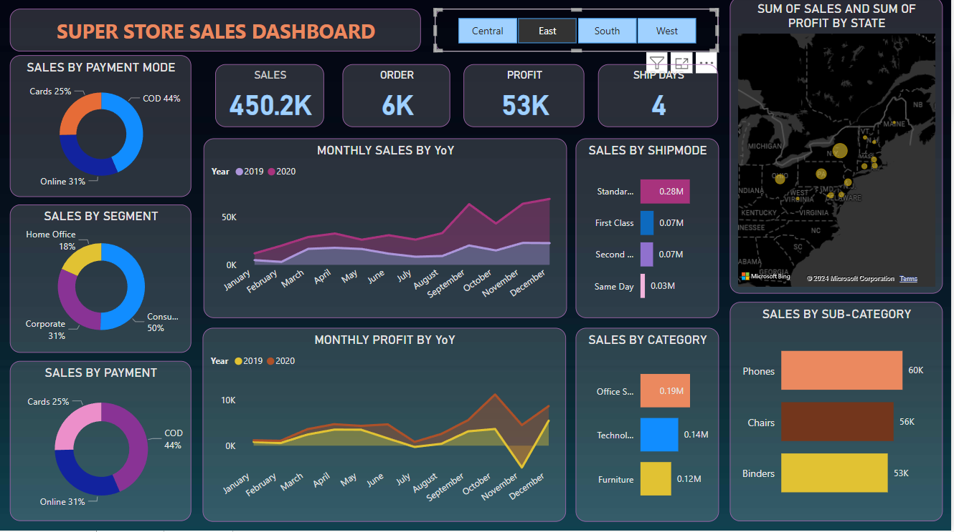

* **SOUTH REGION:**

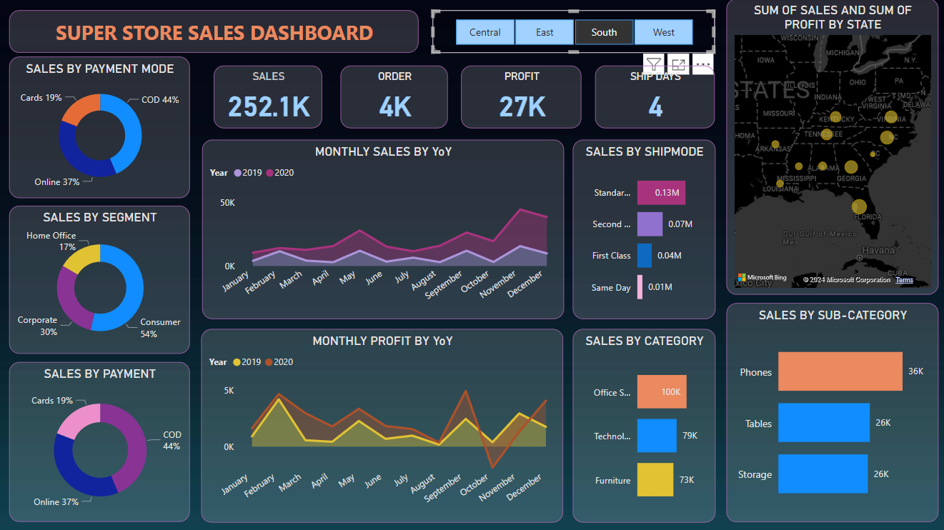

* **WEST REGION**

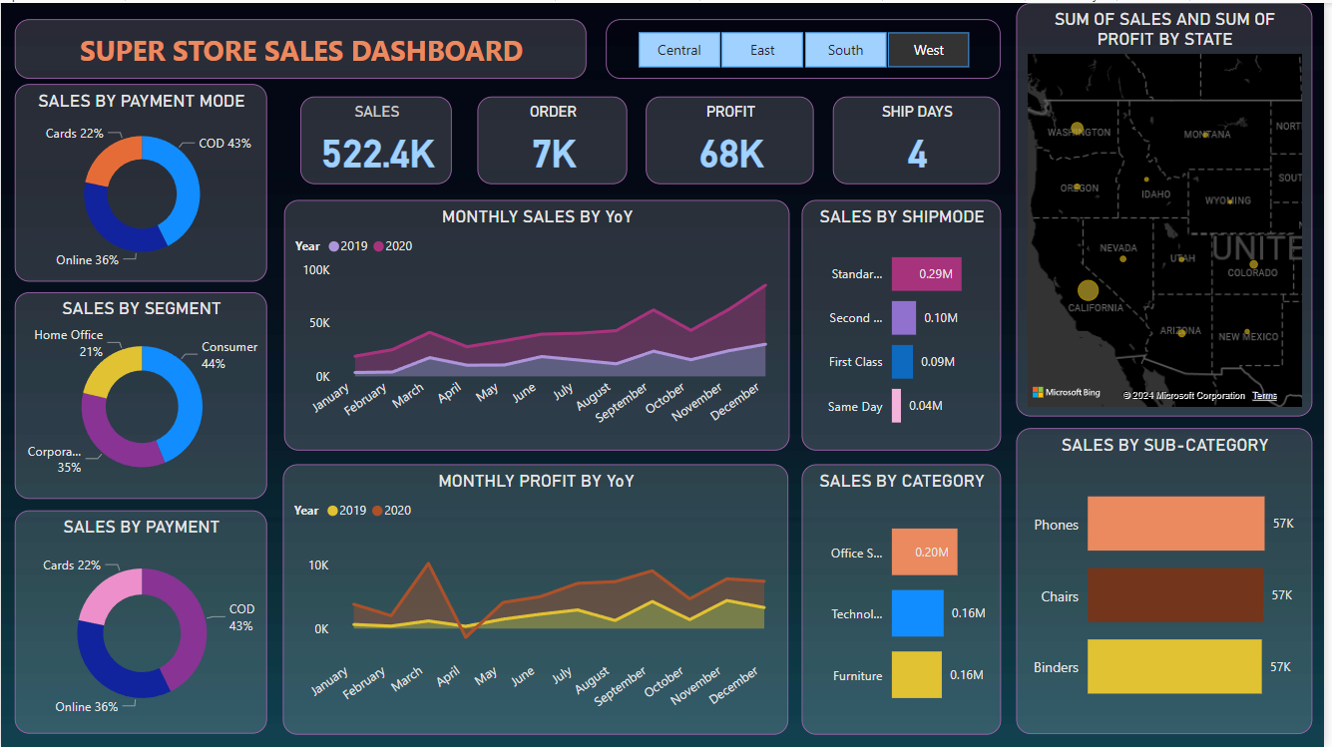

**SALES FORECASTING:**

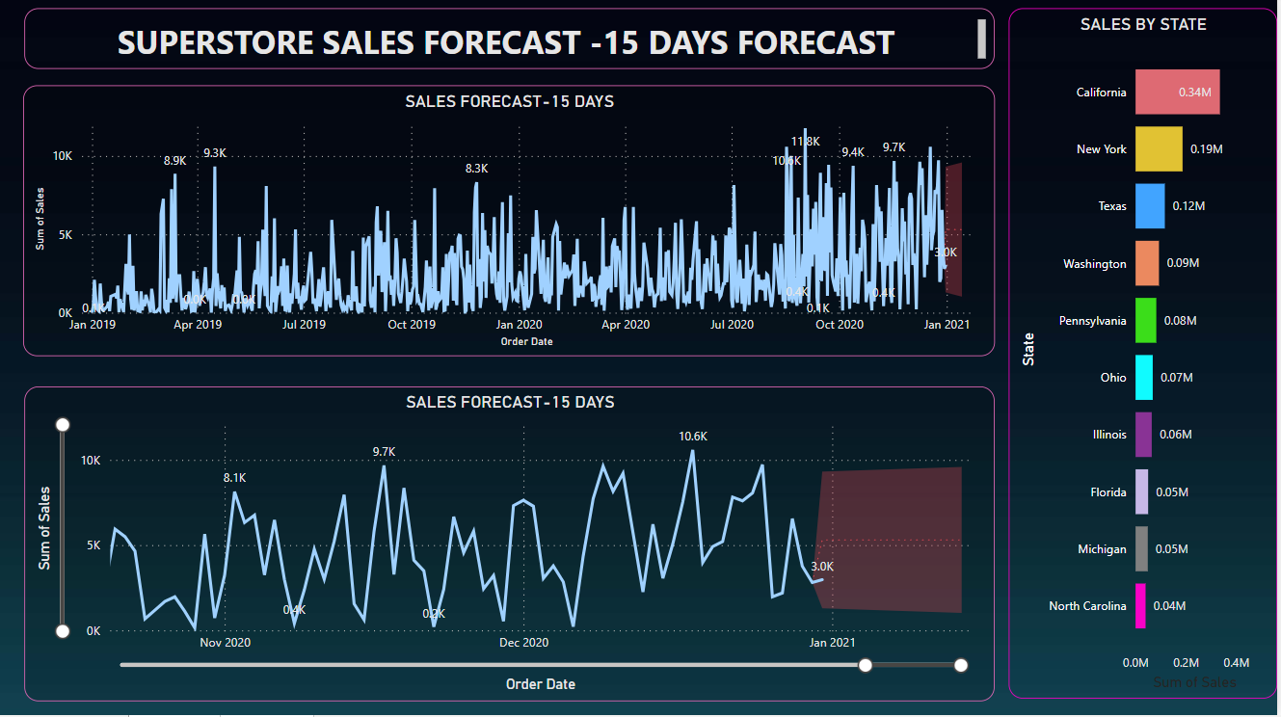

**LEARNING:**

Incorporated data analysis techniques, specializing in time series analysis, to deliver valuable insights, accurate sales forecasting, and interactive dashboard creation, driving business success.

**THANK YOU!**